**PSpice 연습 I**

**제출마감 일시 : 2020년 3월 28일 17:00**

**마감일시까지 제출한 수강생에 대해 출석 인정**

Two-stage capacitively coupled amplifier

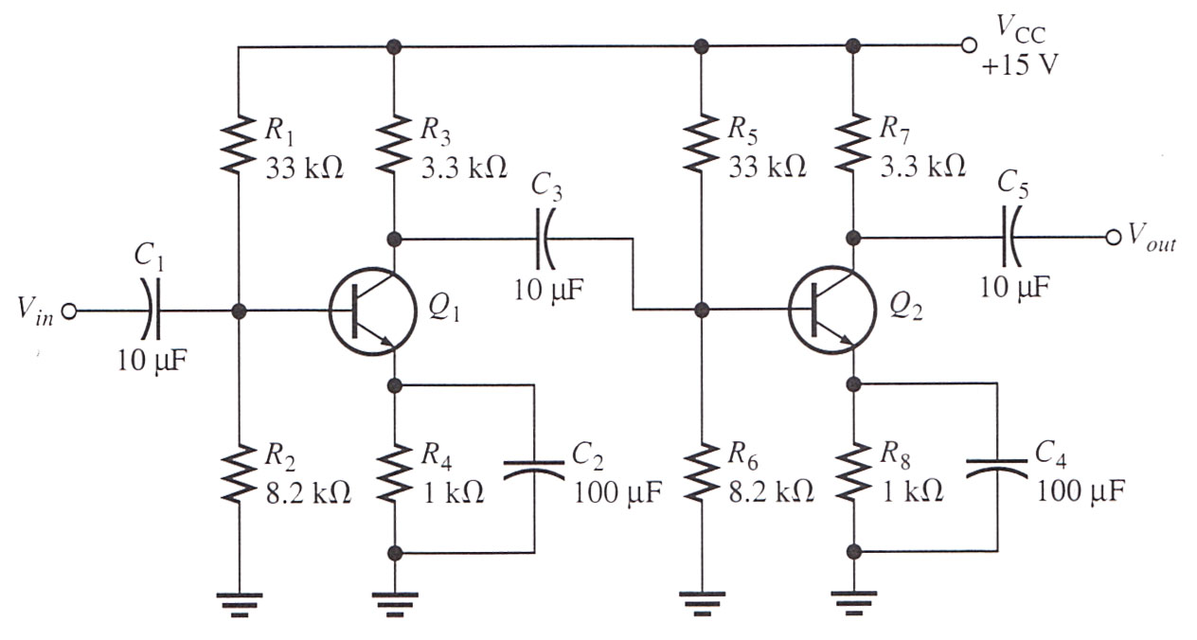

Q2N2222, Driven by a 75 ohm, 50 uV, 1 kHz sine wave source and 18 kohm load.

1. I-V characteristic curves for Q2N2222 (DC sweep analysis)
2. Draw the circuit diagram (Getting the parts, Placing the parts, Connecting the parts, Changing the name of the parts, Changing the value of the part)
3. Operating point of each transistor (Bias point detail and Save bias point analysis)
4. Voltage gain of each stage and overall voltage gain (AC sweep analysis and Probe)
5. -3dB frequency with respect to C4 (Parametric analysis for 100 uF, 300 uF, 500 uF and Probe)
6. Transient analysis with 75 ohm, 50 uV, 1 kHz sine wave source (5 cycles and Probe)
7. Fourier analysis with 75 ohm, 50 uV, 1 kHz sine wave source (10cycles)

$v\left(2πft\right)=C_{0}+ \sum_{n=1}^{∞}{C_{n}∙\sin\left(n∙2πft+∅_{n}\right)}$

where C0 is DC component and Cn is nth harmonic component.

1. Check the output file